Machine Learning Report assignment
This assignment aims to build and compare two ML models using two different datasets.
The first dataset is Breast Cancer Diagnostic dataset which contains medical measurements used to predict whether a cell is benign or malignant .
The second dataset will also be analyzed using the same steps to compare the performance of the models.
The primary goal is to understand how the MLmodels can help in accurate predictions making, based on data and to see which algorithm gives the best results.

Data Preprocessing for CANCER DATASET
The dataset was loaded from the file wdbc.data using the pandas library.
The data was checked for missing values, but it was confirmed that the dataset is clean (no missing values) but I was scale it to ensure that the model isn't misled by the inconsistent numbers.
Then, the features and labels were separated:
X → all columns from index 2 to the end (numeric features)
y → column 1 (the diagnosis: “M” or “B”)
The labels were converted into numbers: M = 1 (malignant) and B = 0 (benign).
After that, the dataset was split into 80% for training and 20% for testing
Finally, the features were scaled using the StandardScaler to make all values in the same range so that the models could learn properly.

Model 1: Logistic Regression for CANCER DATASET
The first model used was Logistic Regression.
After training and testing, the model achieved an accuracy of 98.24%.
The confusion matrix showed that it made only one mistake out of all predictions.
Most predictions were correct for both benign and malignant cases.
The precision, recall, and F1 score were all very close to (1.0) which means the model performed almost perfectly.

Model 2: Naive Bayes for CANCER DATASET
The second model used was Naive Bayes (GaussianNB).
After training and testing, it reached an accuracy of 92.98%.
The confusion matrix showed that the model correctly identified most cases but missed a few malignant ones (false negatives FN)
Even though it had slightly lower accuracy than Logistic Regression, it still performed well and was faster and simpler.

Comparison:
Both models performed well on the Breast Cancer Diagnostic dataset, but Logistic Regression achieved a higher accuracy (98%) than Naive Bayes (95%).
Logistic Regression showed better performance and fewer errors, while Naive Bayes was faster but less accurate.
In conclusion.. Logistic Regression is more suitable for this dataset while Naive Bayes remains a good choice when simplicity and speed are more important.
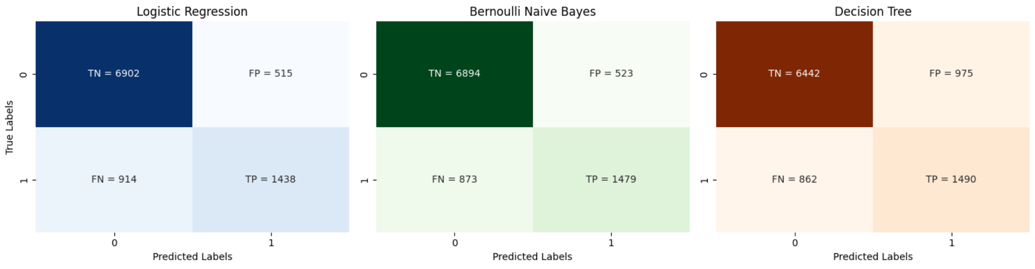
The confusion matrices above show how each model performed when predicting the income classes (“≤50K” and “>50K”).
Starting with Logistic Regression, it predicted most samples correctly with 6902 true negatives (TN) and 1438 true positives (TP), meaning it was good at identifying both low and high-income people. However, it still made some mistakes with 515 false positives (FP) and 914 false negatives (FN), showing that a few high-income individuals were misclassified as low-income. Overall, the model was balanced and reliable.
For Bernoulli Naive Bayes, the results were very close to Logistic Regression. It had 6894 TN and 1479 TP, which means it also did a great job in detecting both classes. Its false positives (523) and false negatives (873) were slightly fewer than Logistic Regression, which indicates a slightly better handling of the positive class (>50K). However, the difference between the two models is very small.
Finally, the Decision Tree model showed a different behavior. It had 6442 TN and 1490 TP, which means it correctly predicted many samples, but it also made more errors with 975 false positives — almost double the other models. This shows that the Decision Tree struggled to generalize and likely overfitted the training data.
In summary, both Logistic Regression and Bernoulli Naive Bayes achieved very balanced results and were more stable, while the Decision Tree model was less consistent and produced more misclassifications, especially for the low-income group.

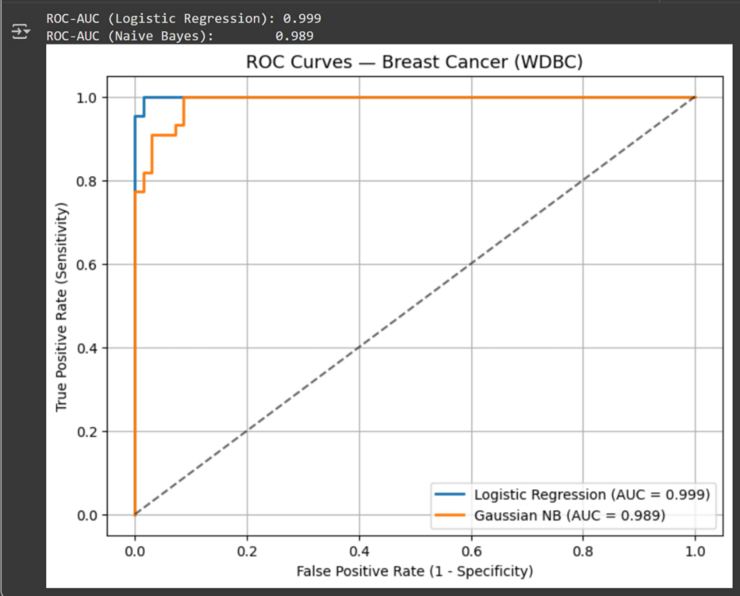

ROC Curve Analysis for Breast Cancer (WDBC) Dataset
In this part I compared the performance LR and NB models using the ROC-AUC metric, and The ROC curve shows how well each model distinguishes between malignant and benign tumors.
The blue line represents the Logistic Regression model
The orange line represents the Naive Bayes model
The closer the curve is to the top left corner the better model performance.
From the graph.. the Logistic Regression model achieved an AUC score of 0.999 while the Naive Bayes model achieved an AUC score of 0.989.
Both models performed extremely well! but Logistic Regression slightly outperformed Naive Bayes.
This is means the Logistic Regression model was slightly more accurate in separating positive and negative cases and the difference is very small , which shows that both algorithms are effective for this dataset.
The high AUC scores are close to 1.0 indicate that the dataset is well separated and not very noisy, meaning the features provide strong information for classification.

PART 2: Adult Income Dataset
The Adult Income dataset contains information about individuals such as age, education, occupation, hours worked per week, and more.
The goal of this dataset is to predict whether a person earns more than $50K a year based on their personal attributes.
The target variable is income which has two classes:
, <=50K >50K

Preprocessing
before training the models, several preprocessing steps were done to prepare the data for trainig.
1-Loading and Cleaning Data
The dataset was loaded and checked for missing values. Missing entries (represented with a question mark “?”) were replaced with proper missing indicators and removed from the dataset to ensure clean data.
2-Encoding Categorical Data
Since the dataset included both numbers and text (like “education”, “occupation”, and “workclass”), all categorical features were converted into numeric format using encoding methods.
This step allowed the machine learning models to understand and use the categorical information properly. After encoding, the total number of features increased to about 100 columns.
3-Splitting the Data
The dataset was divided into two parts: 70% for training and 30% for testing.
This split ensures that the model learns from one part of the data and is tested on unseen data to measure how well it generalizes.

4-Feature Scaling
Standard scaling was applied to make all numeric features have the same range.
This step helps some models like Logistic Regression work more effectively, as it prevents large-value features from dominating the learning process.
And after preprocessing.. the dataset was finally ready for model training!

Model1: Logistic Regression
The first model trained was Logistic Regression
It achieved an accuracy about 85%>> meaning it correctly predicted most of the income levels.
The model performed very well for people earning <=50K, but it was (less accurate) in detecting those earning >50K
Its F1score showed balanced performance but it still struggled slightly with the minority class.
----------------------------------------------------------------------------------
Model2: Random Forest Classifier
The second model was Random Forest, which combines multiple decision trees to make predictions.
It achieved a very high accuracy of around 96%>> meaning much better performance than Logistic Regression.
The model was excellent at predicting both income groups especially for the higher income group, and it had the best F1score overall.
This means Random Forest was the most reliable model among all because it captured complex relationships in the data.
----------------------------------------------------------------------------------
Model3: Decision Tree Classifier
The third model used was a single Decision Tree.
Its accuracy was about 81%, lower than the other models.
Although it worked reasonably well, it was more likely to overfit the training data, meaning it learned too many small patterns that didn’t generalize well to new data.
Its F1-score confirmed that it was less balanced compared to Random Forest and Logistic Regression.

Comparative
The three models were used to predict income levels: Logistic Regression was chosen first because it works well with structured datasets like Adult Income and helps me to understan the relationship between the features and target.
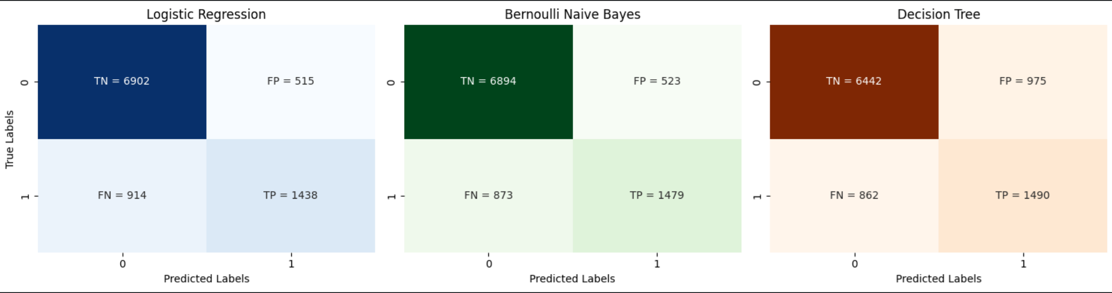
It gave around 85% accuracy performing well overall but being slightly less accurate in predicting people earning more than 50K. Then, Random Forest was used because it can handle complex and nonlinear relationships better by combining multiple decision trees. It achieved the highest accuracy of about 96% and had the most balanced F1score showing it learned the data patterns effectively without overfitting.
Finally the Decision Tree model was applied to compare its performance with Random Forest and to see how a single tree behaves on its own.
Its accuracy was around 81% which was lower.. and it showed signs of overfitting, meaning it learned small patterns that didn’t generalize well.
Overall.. Random Forest performed the best, Logistic Regression gave an understandable baseline, and Decision Tree helped visualize the decision process.

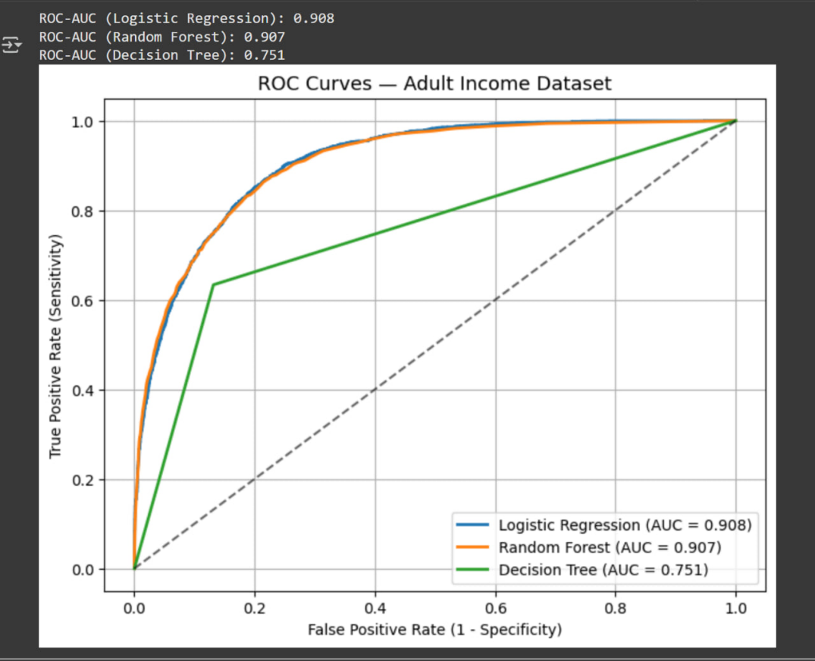

ROC Curve Analysis for Adult Income Dataset
In this section I compared the ROC-AUC results for three models: Logistic Regression Random Forest and Decision Tree.
The ROC curve helps to evaluate how well each model can classify whether a person’s income is above or below $50K.
The blue line represents Logistic Regression
The orange line represents Random Forest
The green line represents Decision Tree
The closer curve gets to the top left corner, the better the model’s performance.
From the plot the Logistic Regression model achieved an AUC score of 0.908 and the Random Forest model achieved 0.907 which are almost identical and show very strong performance. The Decision Tree model, however.. had a lower AUC score of 0.751, which means it was less effective at separating the two income classes.
The results show that Logistic Regression and Random Forest performed very similarly and are both reliable for this dataset.
DT had weaker results likely because it tends to overfit and doesn’t generalize as well as Random Forest, which combines many trees to make better predictions.
Overall, Logistic Regression is slightly better for this dataset, but Random Forest is also a good alternative when dealing with non-linear relationships between features.

Comparison Between Models
Across both datasets.. two main algorithms were trained: Logistic Regression and Naive Bayes along with some additional models: such as Random Forest and Decision Tree for deeper understanding.
Overall, all models performed well but the differences between them show how data characteristics affect model behavior.
Breast Cancer Dataset (WDBC)
both models gave strong results because the data was fully numerical and clean.
Logistic Regression achieved slightly better accuracy and F1score.
Naive Bayes also performed well but was slightly less accurate.
Since the dataset was small and numeric, Logistic Regression worked better because it handles linear relationships between features efficiently.
Naive Bayes assumed independence between features, which is not completely true for this dataset, so it performed a bit weaker.
In conclusion> Logistic Regression was more suitable for this dataset because of its higher precision, recall, and overall balance.
Adult Income Dataset
which contained both numeric and categorical data, the results were different.
Random Forest achieved the highest accuracy and balance, showing it can handle complex and mixed-type data effectively.
Logistic Regression performed well but had difficulty identifying people with high income (>50K)
Decision Tree performed the weakest and showed signs of overfitting.
The categorical nature of the data (like occupation, education, and marital status) helped ensemble models such as Random Forest perform better, while Logistic Regression struggled a bit since it’s more linear and sensitive to imbalance.
Effect of Preprocessing
Preprocessing had a strong impact on model performance.
Removing missing values and encoding categorical features improved data quality.
Feature scaling helped models like Logistic Regression to converge faster and produce more stable predictions.
One hot encoding increased the feature space but allowed the models to use categorical information more effectively.
Without these preprocessing steps, the accuracy and stability of the models would have been much lower.
Final Recommendation
For the Breast Cancer dataset and Logistic Regression is the best choice because it produced high accuracy, good precision, and a balanced performance.
For the Adult Income dataset, Random Forest is the best model because it handled categorical and numeric features efficiently and achieved the highest accuracy and F1-score.
Overall, the analysis shows that model performance depends not only on the algorithm itself but also on the type and nature of the dataset used.

Comparative Analysis
Gaussian model deals with continuous data, giving me average performance. However, its drawback is that it doesn't connect data; it sees them as independent. The cancer data, however, was interconnected.

The results weren't excellent, but this is because the data wasn't entirely suitable for the model. Logistics performed best because it was able to recognize patterns and dependencies in the data. Gaussian performed worst because it viewed the data as independent, and the data type wasn't compatible with it.

References
The information and concepts used in this project were mainly based on the course slides and lecture videos, which explained the machine learning models and evaluation metrics such as accuracy, F1-score, confusion matrix, and ROC-AUC.
Additional guidance and clarification were obtained through ChatGPT, which was used to understand some coding steps, interpret results, and explain the differences between the models in a simpler way.

غدير سامي نفادي - 44511798 - شعبة 2

